**TASK**

|  |  |
| --- | --- |
| Date | 13th October 2022 |
| Team ID | PNT2022TMID25979 |
| Project Name | Project – Project Design Phase -2 Data Flow Diagram And User Stories |
| Maximum Marks | 4 Marks |

**DATA FLOW DIAGRAM AND USER STORIES**

**DATA FLOW**

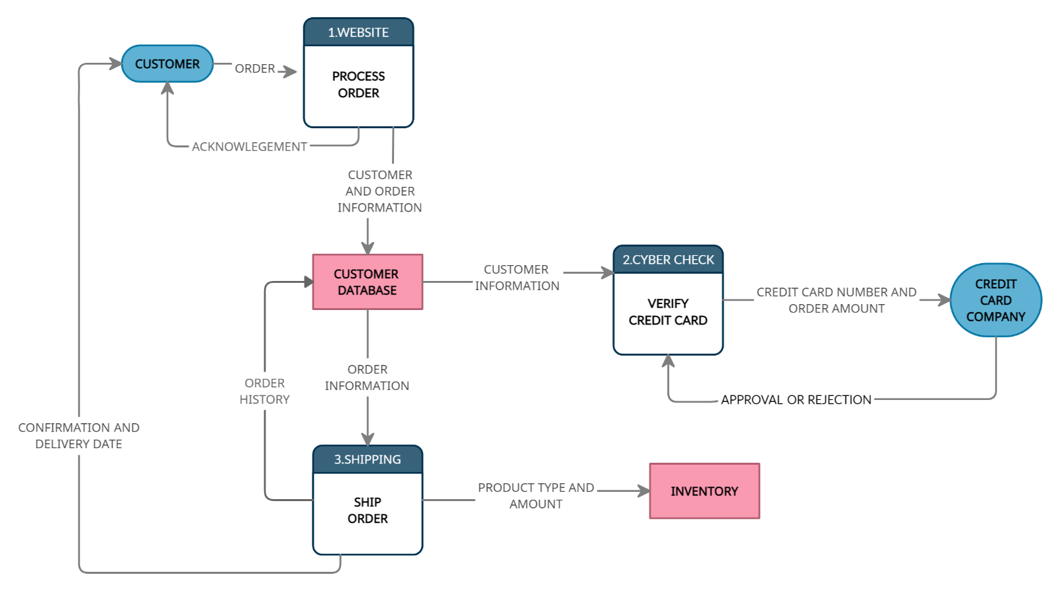

**USER STORIES**

|  |  |  |  |  |  |  |
| --- | --- | --- | --- | --- | --- | --- |
| **USER TYPE** | **FUNCTIONAL REQUIREMENT** | **USER STORY NUMBER** | **USER STORY/TASK** | **ACCEPTANCE CRITERIA** | **PRIORITY** | **RELEASE** |
| Customer | Registration | USN1 | User realizes that they do not have an account, and wants to create one now | Register | High | Sprint 1 |
|  |  | USN2 | User entered the correct credentials for authentication | Successful Registration | High | Sprint 1 |
|  |  | USN3 | User entered incorrect credentials for authentication | Unsuccessful Registration | Medium | Sprint 1 |
|  | Login | USN1 | User entered the correct credentials for authentication | Successful Login | High | Sprint 1 |
|  |  | USN2 | User entered incorrect credentials for authentication | Unable To Login | High | Sprint 1 |
|  |  | USN3 | User realizes that they forgot the credentials | Forgot Credentials | High | Sprint 1 |
|  | Dash Board | USN1 | For finding the products that match the search criteria, use the following attributes in the order | Product name  Product variation name  Product short description  Product long description  Product reviews | High | Sprint 1 |
|  |  | USN2 | For finding the categories that match the search criteria, use the following attributes in the order listed below. | Category name  Category short description | Medium | Sprint 1 |
|  |  | USN3 | Full and partial match should be attempted. | For a partial match, at least 3 characters should match. A minimum of 3 characters needs to be entered to find a match. | High | Sprint 1 |
|  | Customer Care Executive | USN1 | Payment gateway connectivity problem | Send order details to the fulfilment system within 30 minutes of customer completing the checkout process | Medium | Sprint 1 |
| Administrator | Web Page | USN1 | It should be possible to configure via the administration console the date range during which this banner needs to be displayed. | The user should be mandated to enter both the ‘from’ and ‘to’ dates for the date range.   The banner should automatically appear and disappear according to the date range. | High | Sprint 1 |
|  |  | USN2 | It should be possible to configure the banner such that it is personalized for each user. The following four user segments should be available for this configuration. | Anonymous user  Signed-in user who is not a loyalty program member  Signed-in user who is a loyalty program member but has no loyalty points  Signed-in user who is a loyalty program member and has at least one loyalty point | Medium | Sprint 1 |
|  |  | USN3 | For each user segment, it should be possible to configure the image and the link upon clicking the image. | Anonymous user - <image link> - link to “registration page”  Signed-in user who is a loyalty program member but has no loyalty points - <image link> - no link | Low | Sprint 2 |